**Test Scenarios**

1. Validate the Quote Number - before and after accepted the quote are same
2. Validate the Quote Status changed from Sent to Accepted
3. Validate Create Invoice button enabled
4. Validate the Customer Name, Item Description and Quantity are same before and after accepted the quote
5. Validate the History & Note change from Sent to Accepted

Before Accept the Quote

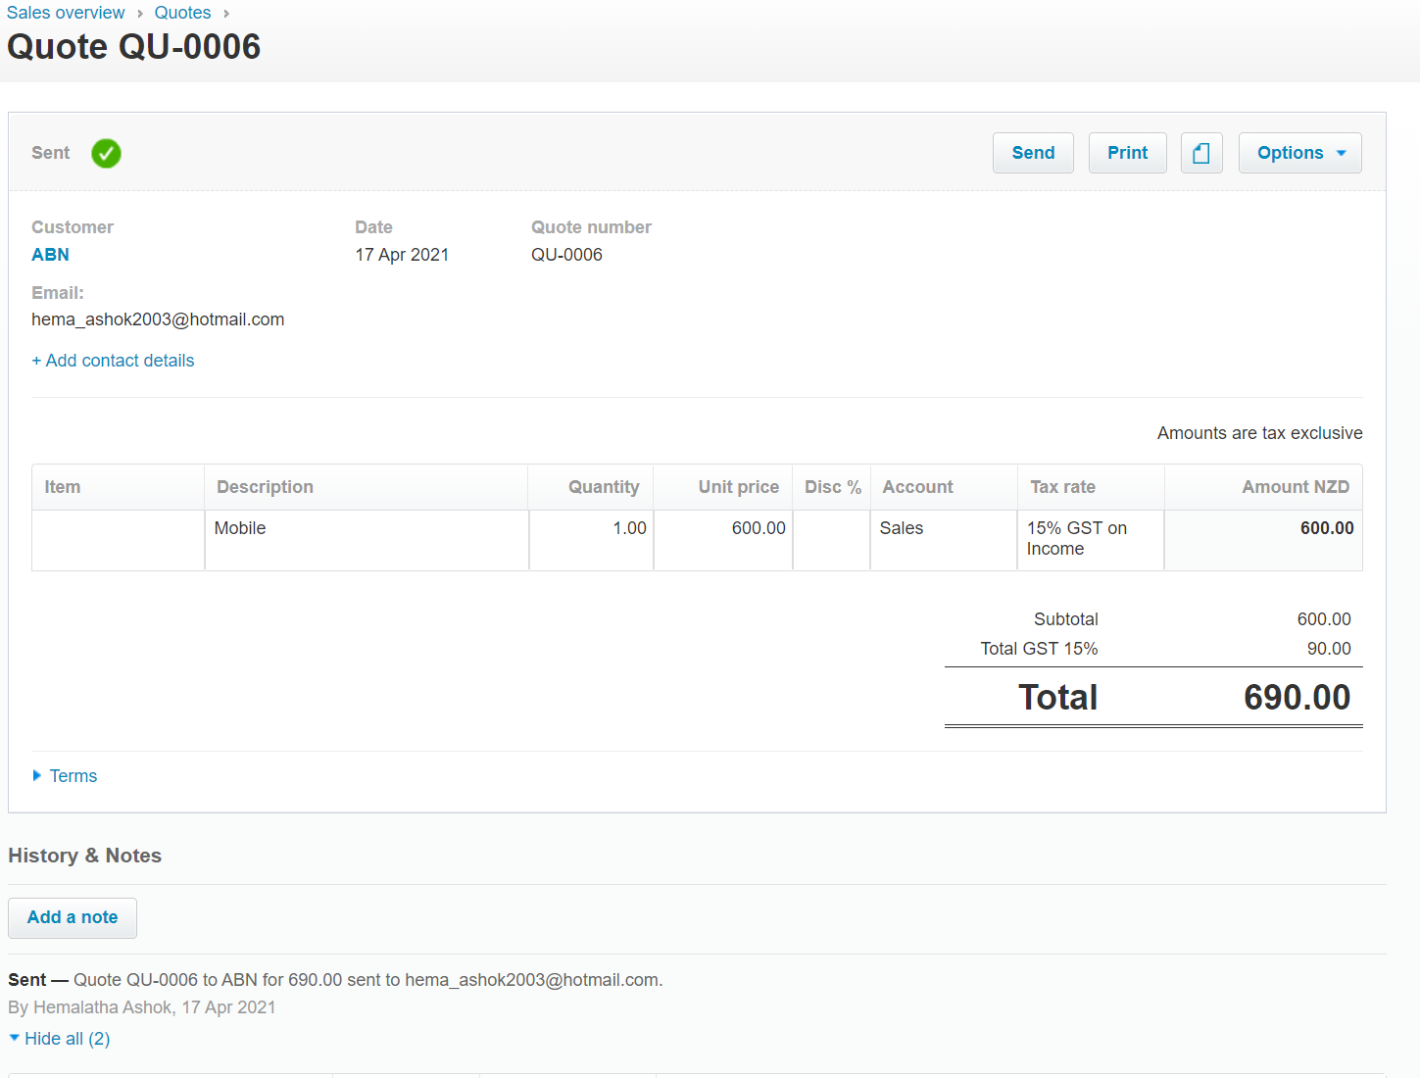

After Accepted the Quote

